Document Reference - [Microsoft Word - PHQ9.doc](https://www.apa.org/depression-guideline/patient-health-questionnaire.pdf)

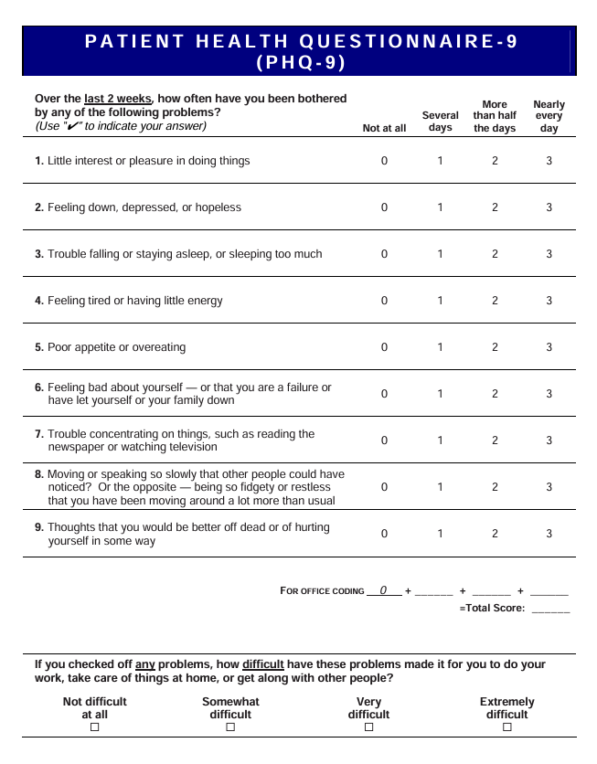

NICE Guidelines

[Depression in adults: treatment and management](https://www.nice.org.uk/guidance/ng222/resources/depression-in-adults-treatment-and-management-pdf-66143832307909)

Data source for Ai-based intervention, and recommendations personalised to user.

DSM-5 Criteria  
The PHQ-9 consists of **9 questions**, each aligned with a DSM-5 criterion for major depressive disorder. These questions cover symptoms such as:

* Low mood or interest
* Sleep disturbances
* Appetite changes
* Fatigue or low energy
* Feelings of worthlessness or guilt
* Difficulty concentrating
* Psychomotor agitation or retardation
* Suicidal thoughts

Each item uses a **4-point Likert scale** (0 = not at all, 3 = nearly every day), enabling quick and precise assessment.

# Scoring Method

The PHQ-9 employs a **4-point Likert scale**, with each item scored from 0 to 3, yielding a total score ranging from **0 to 27**. The scoring process is straightforward:

* Sum the scores of all 9 items.
* Interpret the total score as follows:
  + **0–4**: Minimal or no depression
  + **5–9**: Mild depression
  + **10–14**: Moderate depression
  + **15–19**: Moderately severe depression
  + **20–27**: Severe depression

These cut-off scores guide clinicians in diagnosing depression and researchers in stratifying study participants. Moreover, higher scores indicate greater symptom severity, aiding in treatment planning.

# Mdd_likelihood

Likelihood of **Major Depressive Disorder**

* "**none**" → Symptoms do not align with DSM-5 threshold.
* "**low**" → Some depressive symptoms present, but doesn’t reach 5-symptom threshold OR no impairment.
* "**moderate**" → 5+ symptoms present incl. a core symptom, but mild/moderate severity score and partial impairment.
* "**high**" → Meets full DSM-5 threshold (5+ symptoms, core symptom, 2+ weeks, functional impairment). Strong likelihood of MDD.

# DB Schema

Patients

* + Patient_id
  + Name
  + Age
  + Gender
  + Profession
  + Created_ts

Assessments

* + Assessment_id
  + Patient_id
  + Assessment_date
  + Total_score
  + Severity_band
  + Item9_flag
  + Dm5_snapshot_id

Phq-9_responses

* Response_id
* Assessment_id
* Question_number
* Response_value

Dm5_snapshots

* Snapshot_id
* Coresymptom
* Num_symptoms
* Impairment
* Mdd_liklihood
* Rationale

*PHQ-9 Responses → DSM-5 insights + Journal Insights + Doctors Notes → Analysis → AI Based Interventions + Dasbboards*